1. Download Axis2-1.6.2-bin.zip, axis-2-1.6.2-war.zip files from <http://axis.apache.org/axis2/java/core/download.cgi#a1_5_1>. Download as shown below

**Tip: Maximixze your MSWord then fonts will appear clearly(Observer right corner of word and increase 100 to any value as you like)**

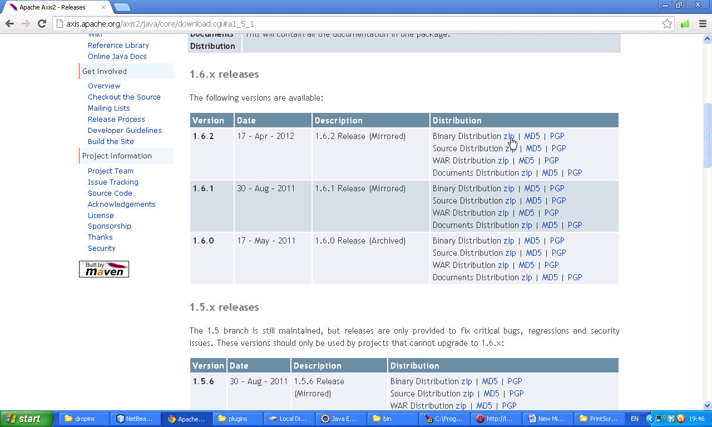

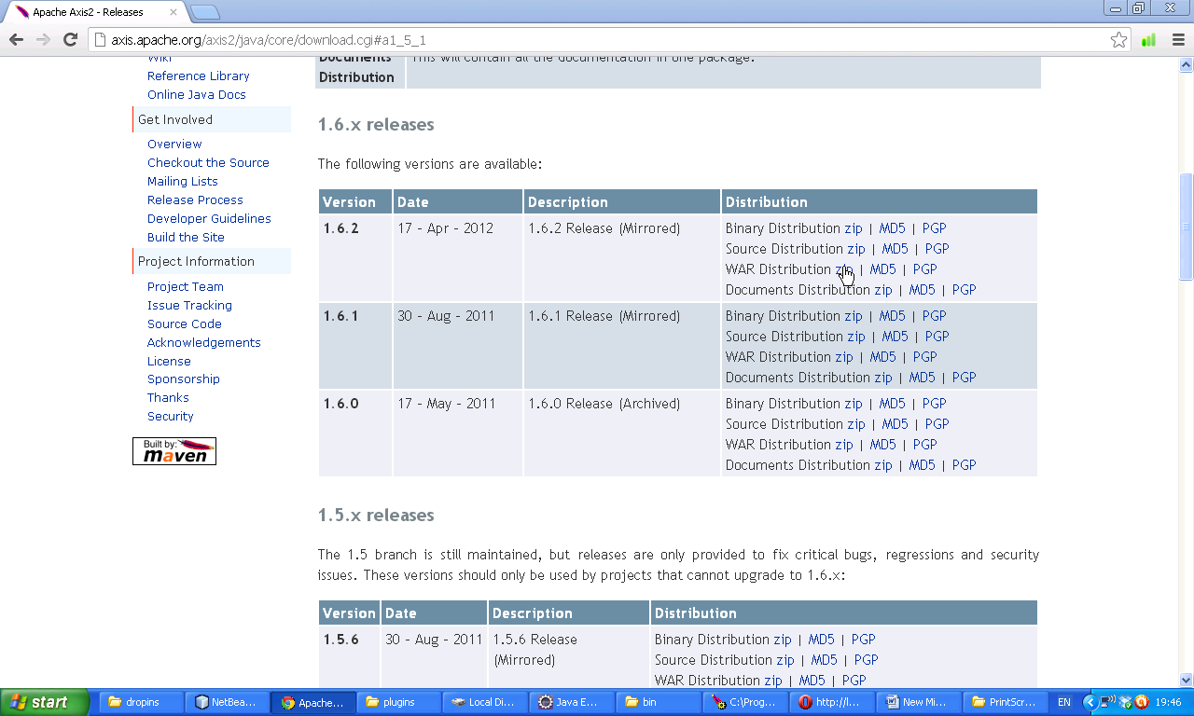Now two zip files are available for us. Extract them we will get axis2.war and and axis2-1.6.2. Now open Axis2 war extraction

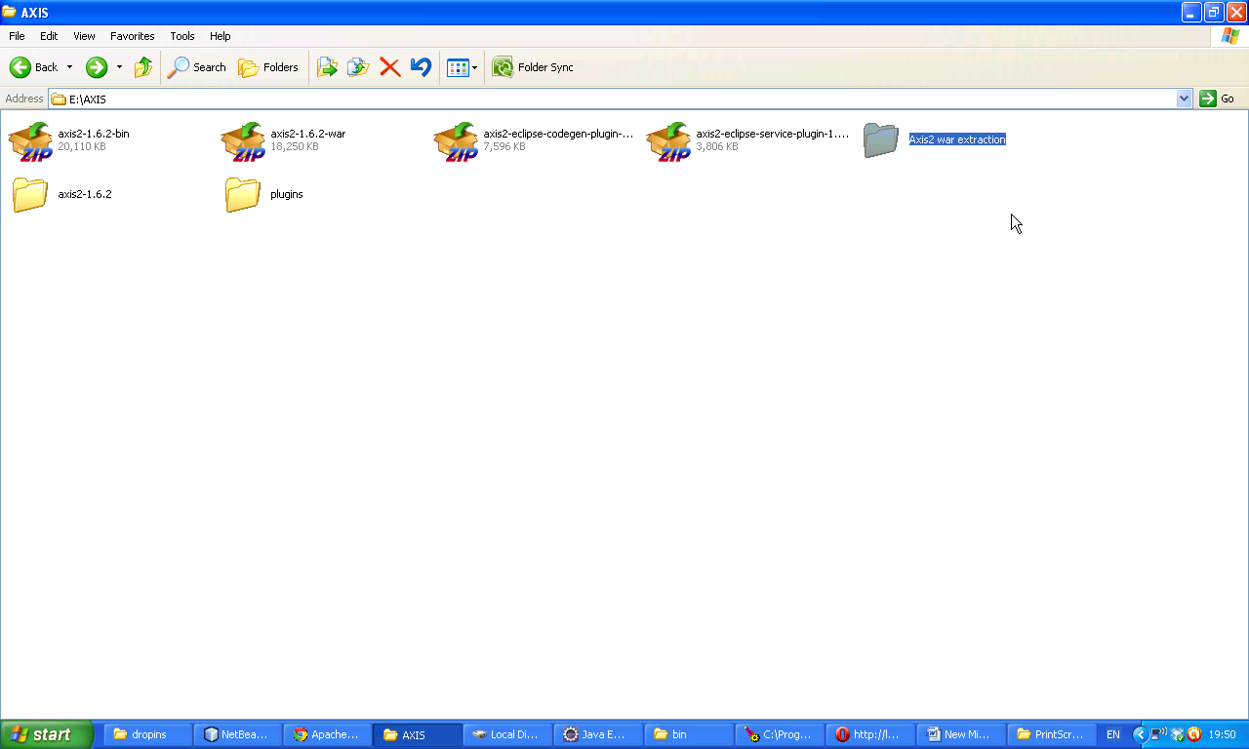

Now following war file is available.

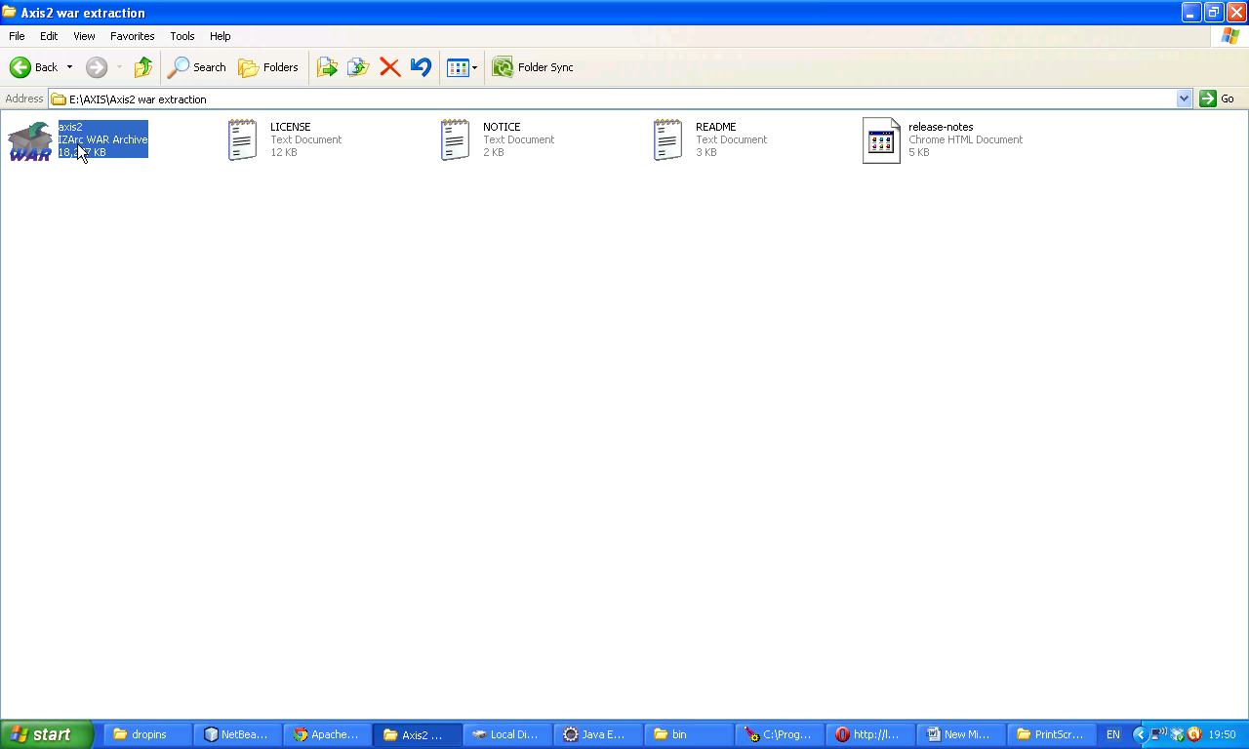

Now paste the axis2.war file in Tomcat/web apps folder. Now open Tomcat for confirmation. Type following url.

<http://localhost:5050/axis2/>

